PTE listening:
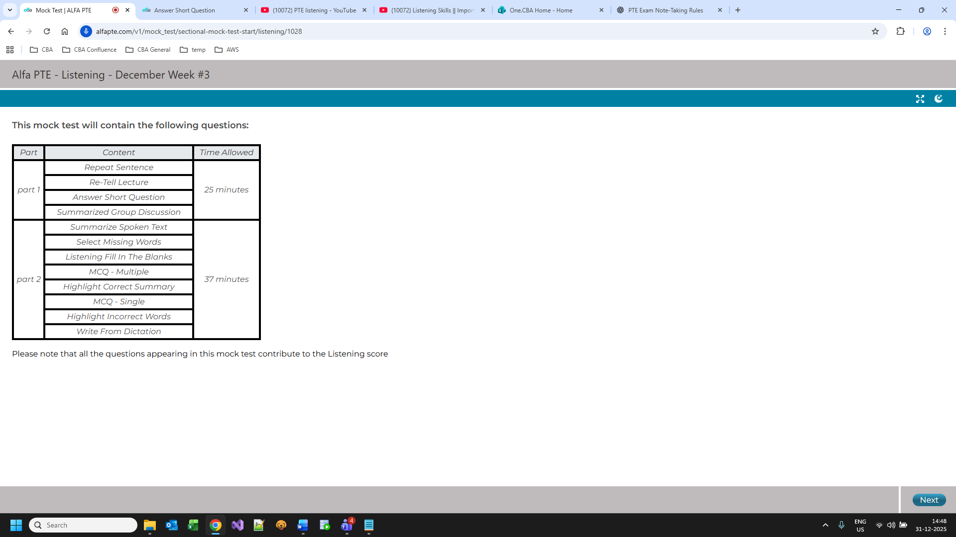
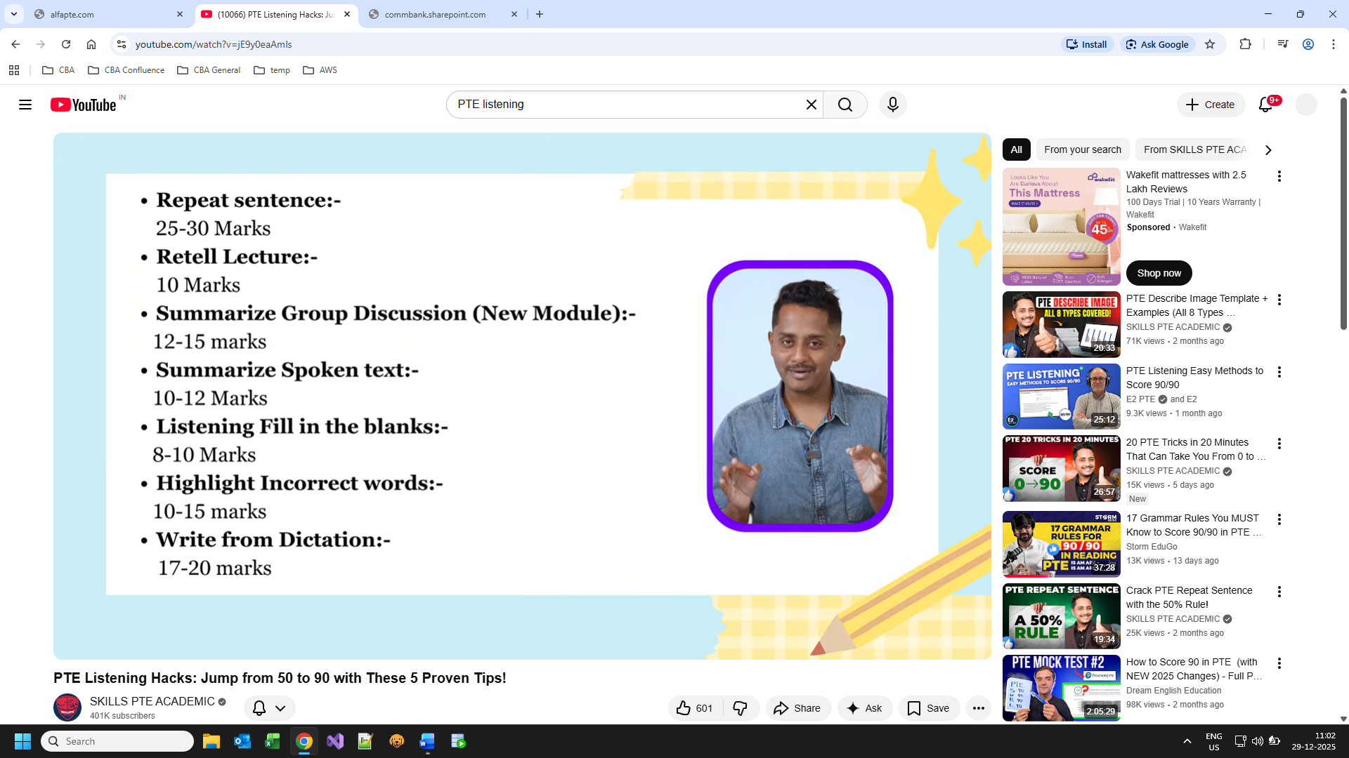

Repeat sentence:
Try to speak 60 – 70 percent correctly as per audio
Retell lecture:
Grab 4 or 5 small sentences exactly from the audio.
Speak for 20 or more seconds at least.
Template:
The lecture mainly talked about...... In the beginning, the speaker told ....... Later speaker explained that .... Later speaker explained that
Group discussion:
3 Speaker and 3 retell lecture for each speaker.
Speak for around 1 to 1.20 mins
The discussion was about heading, and three speakers were involved in the discussion. In the beginning, the first speaker said that, ….
The speaker also mentioned that ….
Furthermore, the speaker stated that ….
Summarise spoken text:
4 to 5 sentences and convert them to meaningful paragraph
Grammatically should be precise and spelling matters here
Mark contributes to Writing and listening
Words should be between 50 and 70.
Write from dictation:
Important question for Writing and listening
Marks based on no of correct words.
Try to write gist of words while listening and then frame it fully.
• ✔️ Capital letters (especially at the start of the sentence) are expected
• ✔️ Full stop (.) at the end is recommended
• Correct words
• Correct spelling
• Correct word order

Fill in the blanks:
Listen audio and type the answer on the go while listening
Answer can be 1 or 2 words
Highlight incorrect words: (Part of reading and listening)
Listen the audio and highlight the words incorrectly spoken
Highlight Correct Summary: (Part of reading and listening)
Listen the audio and highlight the correct summary according to the audio. Only 1 answer
Select missing word:
Listen the audio and at the end would hear a beep sound and have to select the correct word from the options.

